Database

The database is a collection of inter-related data which is used to retrieve, insert and delete the data efficiently. It is also used to organize the data in the form of a table, schema, views, and reports, etc.

**For example:** The college Database organizes the data about the admin, staff, students and faculty etc.

Using the database, you can easily retrieve, insert, and delete the information.

Database Management System

* Database management system is a software which is used to manage the database. For example: MySQL, Oracle, etc are a very popular commercial database which is used in different applications.
* DBMS provides an interface to perform various operations like database creation, storing data in it, updating data, creating a table in the database and a lot more.
* It provides protection and security to the database. In the case of multiple users, it also maintains data consistency.

**DBMS allows users the following tasks:**

* **Data Definition:** It is used for creation, modification, and removal of definition that defines the organization of data in the database.
* **Data Updation:** It is used for the insertion, modification, and deletion of the actual data in the database.
* **Data Retrieval:** It is used to retrieve the data from the database which can be used by applications for various purposes.
* **User Administration:** It is used for registering and monitoring users, maintain data integrity, enforcing data security, dealing with concurrency control, monitoring performance and recovering information corrupted by unexpected failure.

Characteristics of DBMS

* It uses a digital repository established on a server to store and manage the information.
* It can provide a clear and logical view of the process that manipulates data.
* DBMS contains automatic backup and recovery procedures.
* It contains ACID properties which maintain data in a healthy state in case of failure.
* It can reduce the complex relationship between data.
* It is used to support manipulation and processing of data.
* It is used to provide security of data.
* It can view the database from different viewpoints according to the requirements of the user.

Advantages of DBMS

* **Controls database redundancy:** It can control data redundancy because it stores all the data in one single database file and that recorded data is placed in the database.
* **Data sharing:** In DBMS, the authorized users of an organization can share the data among multiple users.
* **Easily Maintenance:** It can be easily maintainable due to the centralized nature of the database system.
* **Reduce time:** It reduces development time and maintenance need.
* **Backup:** It provides backup and recovery subsystems which create automatic backup of data from hardware and software failures and restores the data if required.
* **multiple user interface:** It provides different types of user interfaces like graphical user interfaces, application program interfaces

Disadvantages of DBMS

* **Cost of Hardware and Software:** It requires a high speed of data processor and large memory size to run DBMS software.
* **Size:** It occupies a large space of disks and large memory to run them efficiently.
* **Complexity:** Database system creates additional complexity and requirements.
* **Higher impact of failure:** Failure is highly impacted the database because in most of the organization, all the data stored in a single database and if the database is damaged due to electric failure or database corruption then the data may be lost forever.

# **DBMS Architecture**

* The DBMS design depends upon its architecture. The basic client/server architecture is used to deal with a large number of PCs, web servers, database servers and other components that are connected with networks.
* The client/server architecture consists of many PCs and a workstation which are connected via the network.
* DBMS architecture depends upon how users are connected to the database to get their request done.

## Types of DBMS Architecture

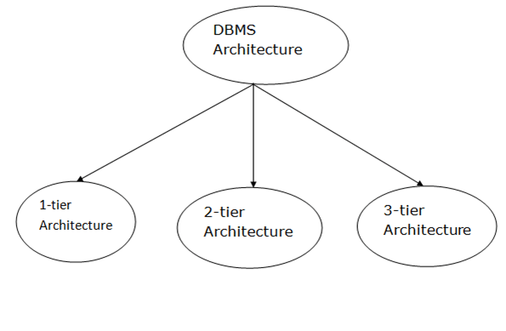

Database architecture can be seen as a single tier or multi-tier. But logically, database architecture is of two types like: **2-tier architecture** and **3-tier architecture**.

### **1-Tier Architecture**

* In this architecture, the database is directly available to the user. It means the user can directly sit on the DBMS and uses it.
* Any changes done here will directly be done on the database itself. It doesn't provide a handy tool for end users.
* The 1-Tier architecture is used for development of the local application, where programmers can directly communicate with the database for the quick response.

### **2-Tier Architecture**

* The 2-Tier architecture is same as basic client-server. In the two-tier architecture, applications on the client end can directly communicate with the database at the server side. For this interaction, API's like: **ODBC**, **JDBC** are used.
* The user interfaces and application programs are run on the client-side.
* The server side is responsible to provide the functionalities like: query processing and transaction management.
* To communicate with the DBMS, client-side application establishes a connection with the server side.

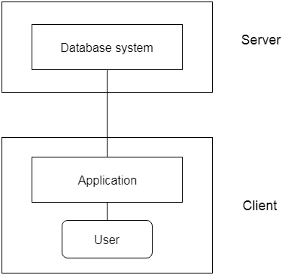

**Fig: 2-tier Architecture**

### **3-Tier Architecture**

* The 3-Tier architecture contains another layer between the client and server. In this architecture, client can't directly communicate with the server.
* The application on the client-end interacts with an application server which further communicates with the database system.
* End user has no idea about the existence of the database beyond the application server. The database also has no idea about any other user beyond the application.
* The 3-Tier architecture is used in case of large web application.

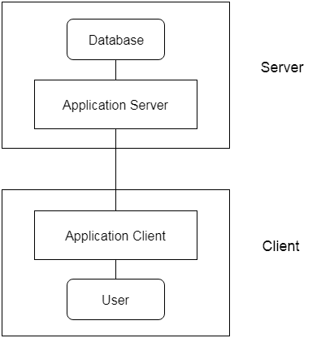

**Fig: 3-tier Architecture**